ASSIGNMENT 3

AIM:
To plot transfer characteristics of NMOS and PMOS transistors for different Vgs and Vds.
CIRCUIT:
1. NMOS
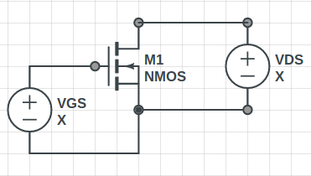

2. PMOS
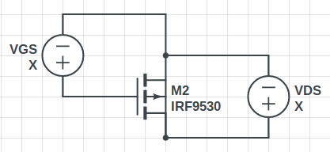

OBSERVATIONS:
1. NMOS Transfer Characteristics
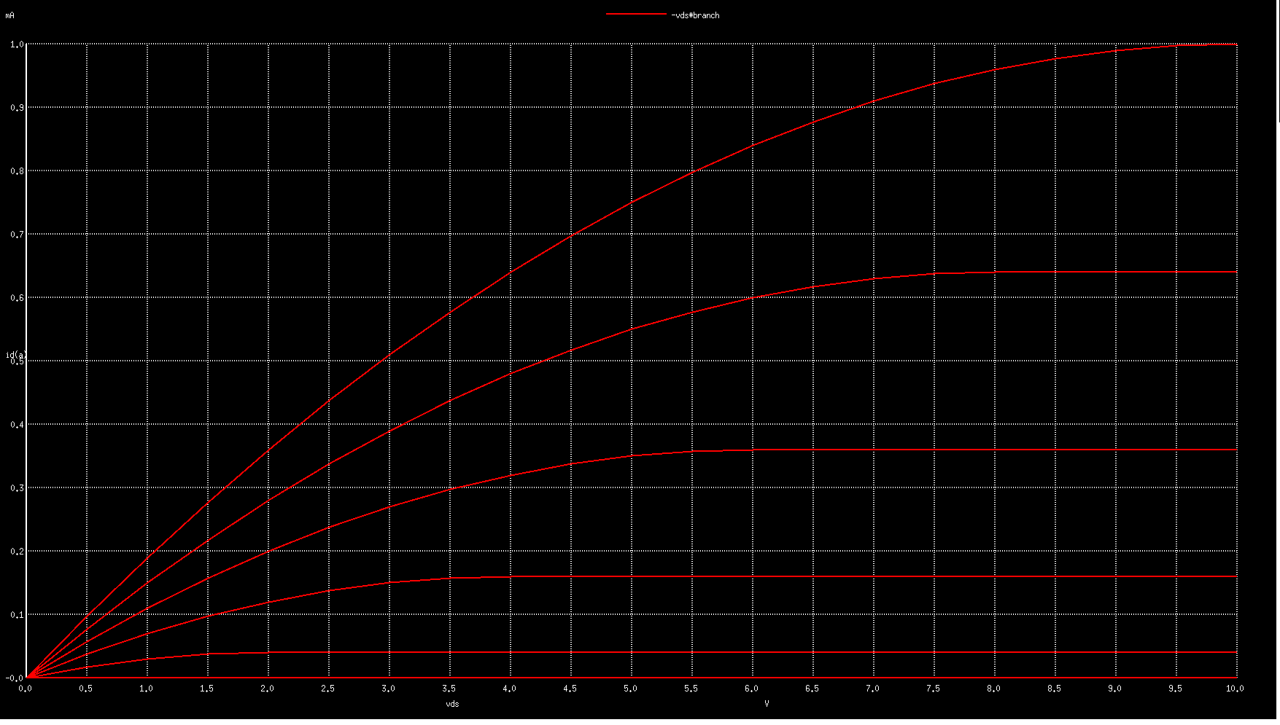

2. PMOS Transfer Characteristics
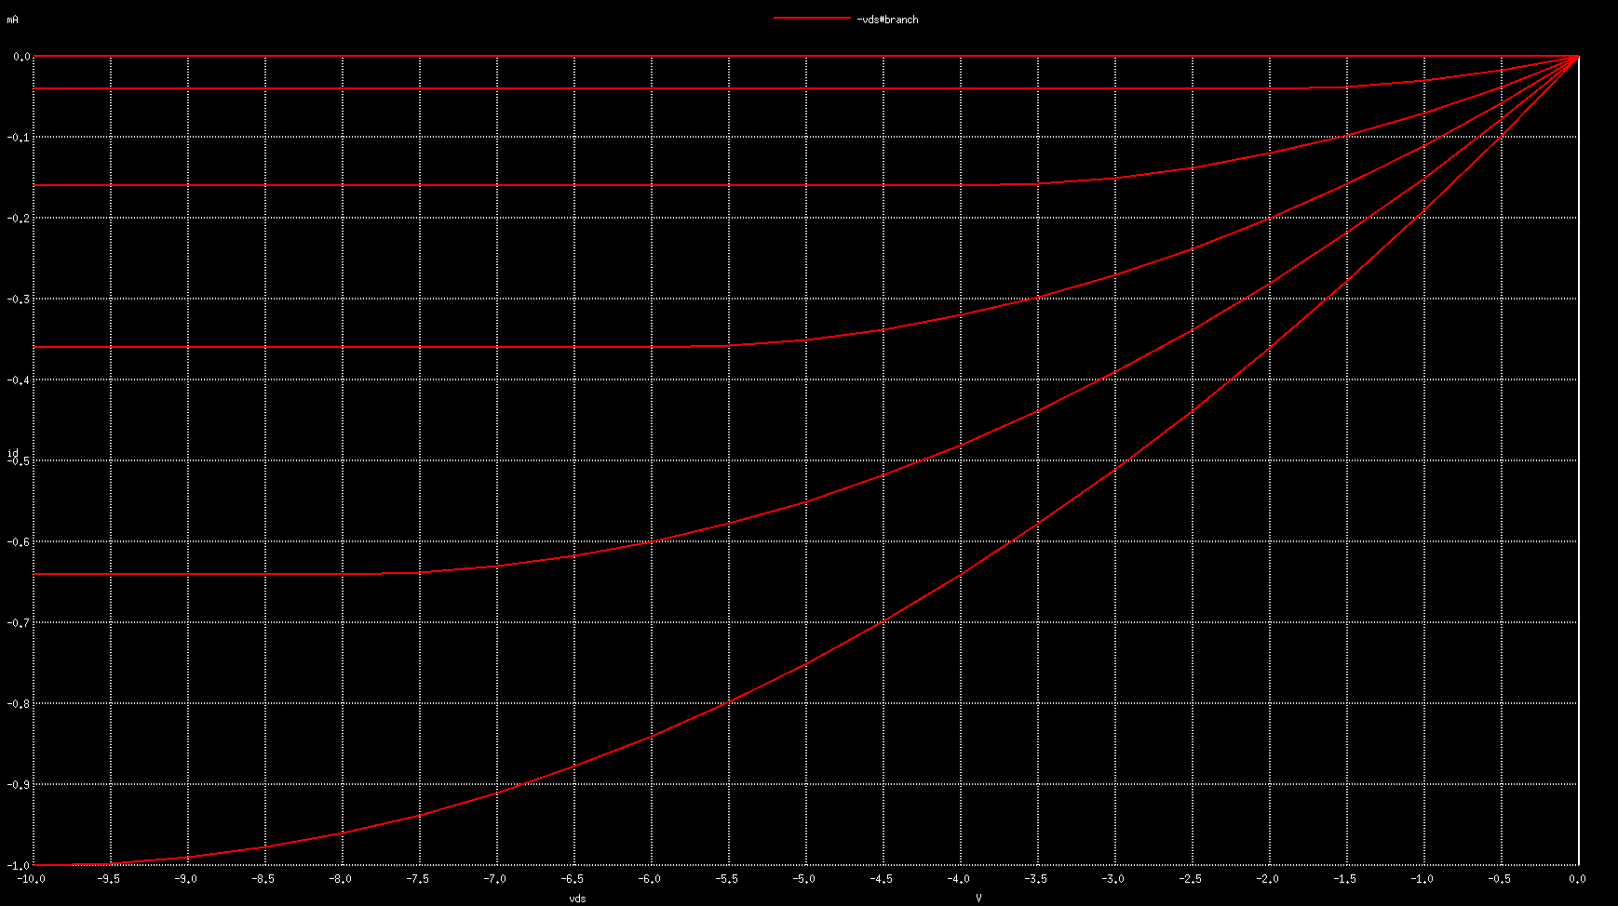

CONCLUSION:
Default NMOS and PMOS configurations were used and the transfer function graph matched the theoritical analysis.

